**Basic Level Understanding of**

**Linear-Regression.**

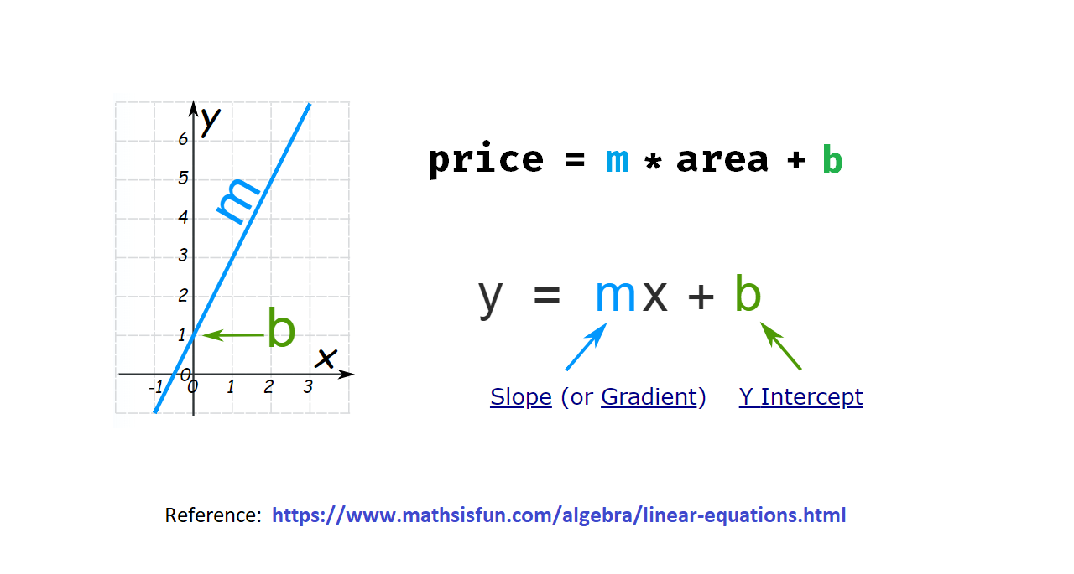

**What is Linear Regression?**

Linear regression is a fundamental statistical method used to model the relationship between a dependent variable (the thing we want to predict) and one or more independent variables (the factors that we think affect the dependent variable). It's called "linear" because it models this relationship as a straight line.

**Key Components:**

1. Dependent Variable (Y): This is what we're trying to predict or explain. In your example, it could be something like house prices.

2. Independent Variable(s) (X): These are the factors that we believe influence the dependent variable. In the case of house prices, it could be the size of the house.

**The Linear Equation:**

Linear regression finds the best-fit line that represents the relationship between X and Y. This line is described by a simple equation:

**Y = mX + b**

- **Y:** The predicted or dependent variable (e.g., house price).

- **X:** The independent variable (e.g., house size).

- **m:** The slope of the line, representing how much Y changes when X changes.

- **b**: The intercept, where the line intersects the Y-axis when X is zero.

**How Does Linear Regression Work?**

Linear regression works by finding the values of 'm' and 'b' that minimize the difference between the predicted Y values (based on the line) and the actual Y values in the data.

**Example:**

Imagine you have data on house sizes and their prices. Linear regression would find the best-fit line (the slope 'm' and intercept 'b') that allows you to predict the price of a house based on its size.

**Use Cases:**

Linear regression is used in many fields, from economics to science, to predict and understand relationships between variables. It's a simple but powerful tool for making predictions and drawing insights from data.

**Limitations:**

Linear regression assumes a linear relationship between variables, which may not always hold in real-world situations. There could be more complex relationships that require more advanced techniques.

**In Summary:**

Linear regression is a basic statistical method that helps us understand and predict how one variable (Y) depends on one or more other variables (X). It's a fundamental building block of data analysis and predictive modeling.